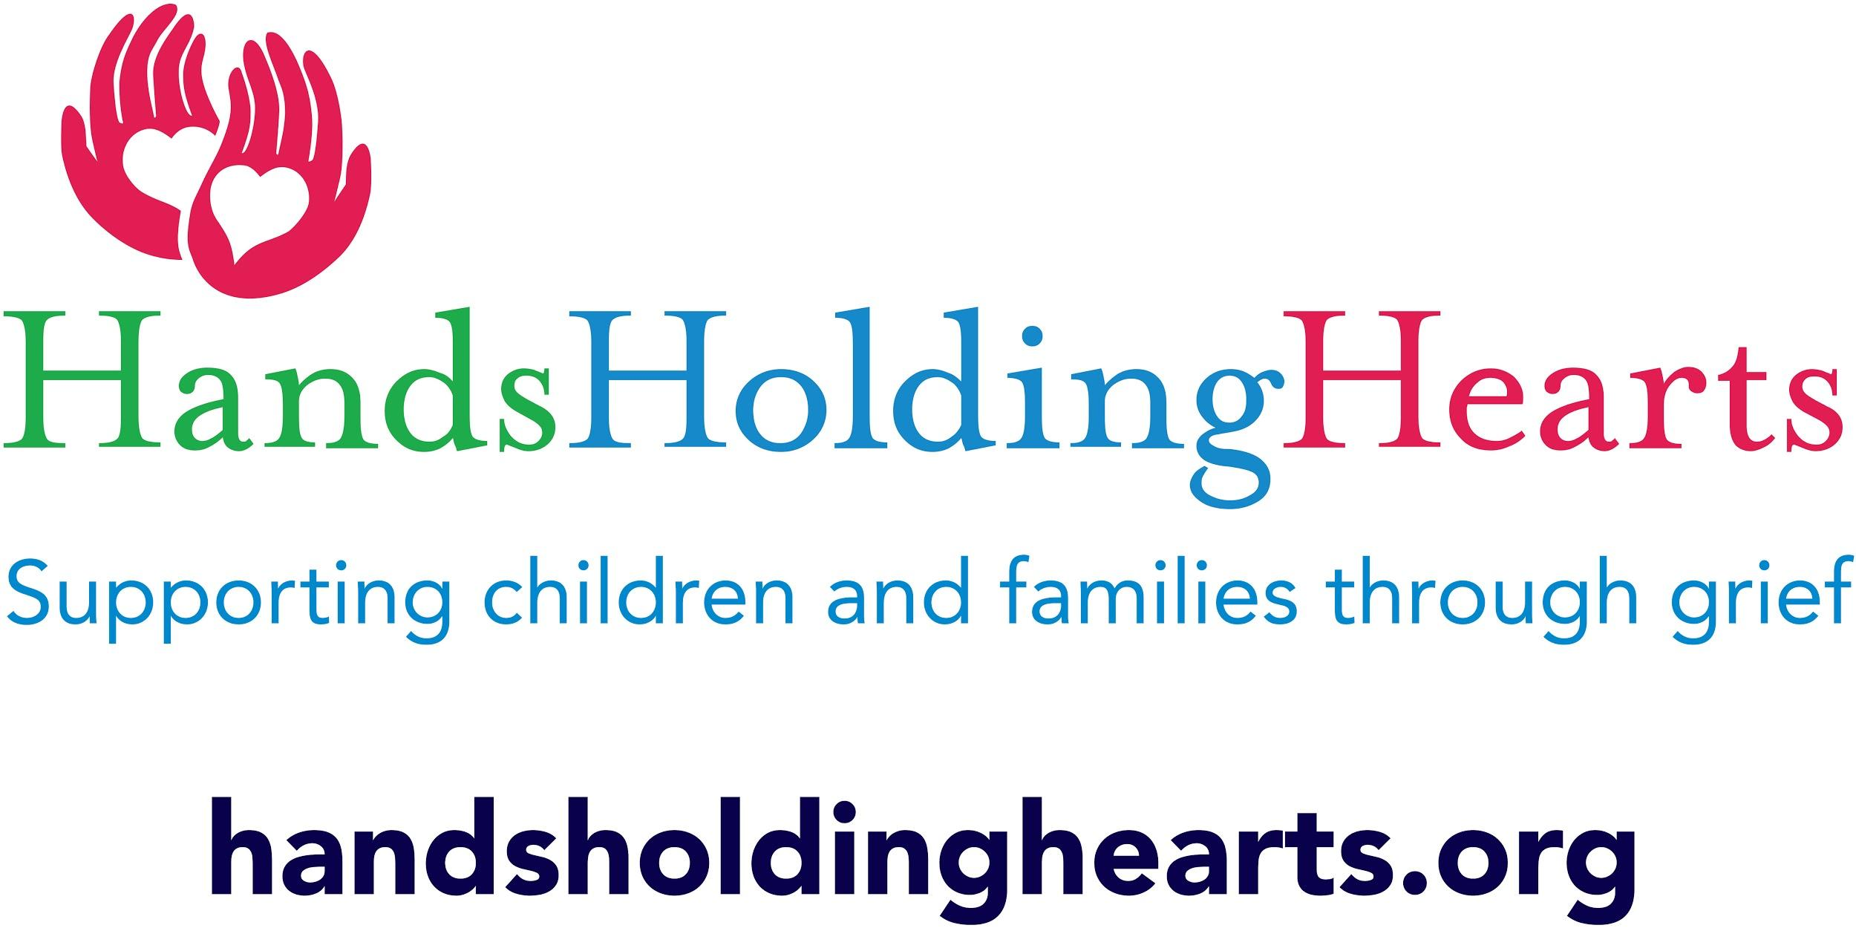

**Bereavement Camp Application**

| Child’s Name | | DOB | Age | | Grade | | |
| --- | --- | --- | --- | --- | --- | --- | --- |
| Address | | City | | | State | Zip | |
| Allergies & reactions: | | | | | | | |
| Parent/Guardian Name: | Telephone (Home):  Telephone (Work ):  Cell Phone :  Email: | | | | | | |
| Guardian’s Address (if different from child) | | | | Cultural/Ethnic Heritage | | | |
| Name of School | | | | Guidance Counselor | | | |
| **Bereavement History** | | | | Age at Death | | | Date of Death |
| Who has died? | | | | | | | |
| Did the child attend the funeral? | | | | | | | |
| What have you told your child about what happens when/after people die? | | | | | | | |
| Do you have specific spiritual or religious beliefs pertaining to death? | | | | | | | |
| Who is in your child’s family? Siblings? Both parents? Grandparents? | | | | | | | |
| What support does your child have? (Family, Friends, school, neighbors, pediatrician, spiritual) | | | | | | | |
| Is anyone significant (family/close friend) seriously ill? | | | | | | | |
| How would you describe your child (in one sentence) before the death? | | | | | | | |
| How would you describe your child now? | | | | | | | |
| What changes have you seen in your child/children since the death(s)? | | | | | | | |
| Are you and/or your child in counseling or therapy? If yes, with whom? (include contact information) | | | | | | | |
| Are there problems that are of particular concern to you about your child? | | | | | | | |
| Please note specific concerns that you would like us to address during this session. | | | | | | | |
| How has your child coped in the past with difficult situations? | | | | | | | |

Please note below any other losses or changes that the child/family has experienced.

|  | Explain | Date |
| --- | --- | --- |
| Divorce or separation |  |  |
| Ended relationship(s) |  |  |
| Moving to a new house or community |  |  |
| Changing schools |  |  |
| Friends moving away |  |  |
| Miscarriages/Stillbirths? |  |  |
| Other deaths? Who? |  |  |
| Pet death |  |  |
| Parents changing jobs |  |  |
| Fire or theft loss |  |  |
| Other traumas |  |  |

The list is for you and the child to review **together**. Please indicate concerns pertaining to the child, indicating whether it is new since the death or not by checking the appropriate column. This will help us in planning the rest of our sessions.

| **AREAS OF CONCERN** | | |
| --- | --- | --- |
| **SCHOOL** | Before Illness/Death | After Illness/Death |
| Getting homework done |  |  |
| Using bad language |  |  |
| Disruptions in class |  |  |
| Not getting along with classmates |  |  |
| Not paying attention in class |  |  |
| Daydreaming |  |  |
| Cannot concentrate |  |  |
| Overly tired or sleepy |  |  |
| Dropping out of school |  |  |
| Grades dropping |  |  |
| Skipping school |  |  |
| Absence from school |  |  |
| Other: |  |  |
| **FRIENDS** | Before Illness/Death | After Illness/Death |
| Frequent fighting with them |  |  |
| Lack of interest in friends |  |  |
| Decrease in phone calls |  |  |
| Giving away belongings |  |  |
| Other: |  |  |
| **BEHAVIORS** | Before Illness/Death | After Illness/Death |
| Fighting with siblings |  |  |
| Disrespectful of parents |  |  |
| Eating problems |  |  |
| Sleeping problems |  |  |
| Physical complaints |  |  |
| Withdrawal from activities/friends/parents |  |  |
| Crying frequently |  |  |
| Feeling responsible for death, guilt |  |  |
| Increased anger |  |  |
| Looking sad |  |  |
| Talking about dying/being with deceased |  |  |
| Refusing to talk about the deceased |  |  |
| Clinging behavior |  |  |
| Wetting herself during the day |  |  |
| Thumb sucking/nail biting |  |  |
| Baby talk |  |  |
| Behavior “too good”, overachieving |  |  |
| Other: |  |  |
| **DREAMS** | Before Illness/Death | After Illness/Death |
| About the deceased |  |  |
| About death in general |  |  |
| Recurring dreams |  |  |
| Nightmares |  |  |
| Other: |  |  |

| **FEARS** | Before Illness/Death | After Illness/Death |
| --- | --- | --- |
| Of the dark |  |  |
| Death |  |  |
| Other parent dying |  |  |
| Someone breaking in at night |  |  |
| New experiences |  |  |
| Loud noises |  |  |
| Of going to sleep |  |  |
| Being taken/kidnapped |  |  |
| Other: |  |  |

How did you hear about Camp Feeling Better? _____________________________________________________________________________________________

**

**Parental Consent, Release, and Indemnification Provisions**

I, ________________________________, hereby give permission for my child(ren), _________, to attend Camp Feeling Better. I understand that the camp’s goal is to help facilitate the bereavement process for my family and provide support for us in expressing our grief.

I acknowledge that a screening interview will be required for each child participating; that campers are accepted on a first-come, first-serve basis after it is determined by Hands Holding Hearts that they are emotionally ready to engage in camp, and that priority is given to those who have not yet attended a Hands Holding Hearts camp.

_________________________________________________ _______________

Signature of Parent of Legal Guardian Date

#### Consent to Child(ren)’s Participation in Camp

[___] I hereby consent to participation with the above-indicated child(ren) in the bereavement camp. I agree to seek assistance from Camp Feeling Better Staff or other community support, should I or my child(ren) need further assistance.

I understand that Hands Holding Hearts will take reasonable steps to maintain the confidentiality of others in the group. Exceptions to this policy would include reports of child abuse, the possibility of harm to a child or others, and court-ordered records. I agree that information about my child(ren) provided in the application may be shared with camp counselors who will be working with the child(ren).

I acknowledge that it is the responsibility of the parent/guardian to ensure that children are picked up from camp on time or a late fee of $20 per half hour will be imposed and that the staff is unable to remain at the camp if a long delay occurs.

_________________________________________________ _______________

Signature of Parent of Legal Guardian Date

#### Consent to Photography/Videotaping

[___] I give permission to Camp Feeling Better to photograph and/or videotape myself, and/ or my child(ren) during our activities at the camp. I understand that these videos and photos are the property of Hands Holding Hearts and may be used for educational/promotional purposes now and/or in the future. Examples include a photo in the local paper or given to group participants as keepsakes. If the photo or video is used in a case study, Hands Holding Hearts will take reasonable steps to maintain the confidentiality of any personal information, including child(ren)’s names, ages, and reasons for participating in the camp.

_________________________________________________ _______________

Signature of Parent of Legal Guardian Date

#### Consent to Off-Site Nature Walk

[___] I give permission for my participating child(ren) to leave the site of the camp to engage in a nature walk accompanied by camp staff members, weather permitting.

_________________________________________________ _______________

Signature of Parent of Legal Guardian Date

#### Consent to First Aid/Medical Treatment

[___] If my child(ren) sustains injury or manifests an illness at the camp that requires medical attention or treatment on an emergency basis, I request that Hands Holding Hearts contact the following adults immediately:

EMERGENCY CONTACT #1:

NAME: ______________________________ PHONE NUMBER:__________________

RELATIONSHIP TO CHILD:__________________________

EMERGENCY CONTACT #2:

NAME: ______________________________ PHONE NUMBER:__________________

RELATIONSHIP TO CHILD:__________________________

EMERGENCY CONTACT #3:

NAME: ______________________________ PHONE NUMBER:__________________

RELATIONSHIP TO CHILD:__________________________

Name & phone number of Pediatrician:______________________________________________________________

Medical information needed at time of Emergency:____________________________________________________

Allergies & reactions: ___________________________________________________________________________

Current Medications:____________________________________________________________________________

Health Insurance Provide & Number: _______________________________________________________________

In the event of a medical emergency, if Hands Holding Hearts cannot reach any of the emergency contacts listed above, I authorize Hands Holding Hearts staff to obtain necessary emergency first aid/medical treatment for the above-named child(ren).

**I will not send my child(ren) to Hands Holding Hearts activities if I know that they are ill.

_________________________________________________ _______________

Signature of Parent of Legal Guardian Date

#### 

#### Release and Indemnification Agreement

In consideration of the above-named child(ren) being granted permission to attend Camp Feeling Better, I release and discharge Hands Holding Hearts, their agents, employees, and volunteers and officers, from any and all claims, demands, actions, and judgments which I ever had, now have, or may have against Hands Holding Hearts for personal injuries, either physical or emotional, known, or unknown, and injury to property, real or personal, sustained by me or my property during our attendance at Camp Feeling Better, whether the injury is caused by negligence or any other fault.

Also, in consideration of the above-named child(ren) being granted permission to attend Camp Feeling Better, I agree to indemnify and hold harmless Hands Holding Hearts for any claims, demands, actions, and judgments whatsoever of every name and nature, both in law and equity, which I ever had, now have or have against Hands Holding Hearts for personal injuries, either physical or emotional, known or unknown, and injury to property, real or personal, sustained by me or my property during our attendance at Camp Feeling Better, due to injury caused by or arising from negligence.

I, the undersigned, have read this release and understand all of its items.

_________________________________________________ _______________

Signature of Parent of Legal Guardian Date

*Return completed an application and $25 registration fee for each child. Applications and checks can be sent to 118 N. State St. Newtown, Pa. 18940.*

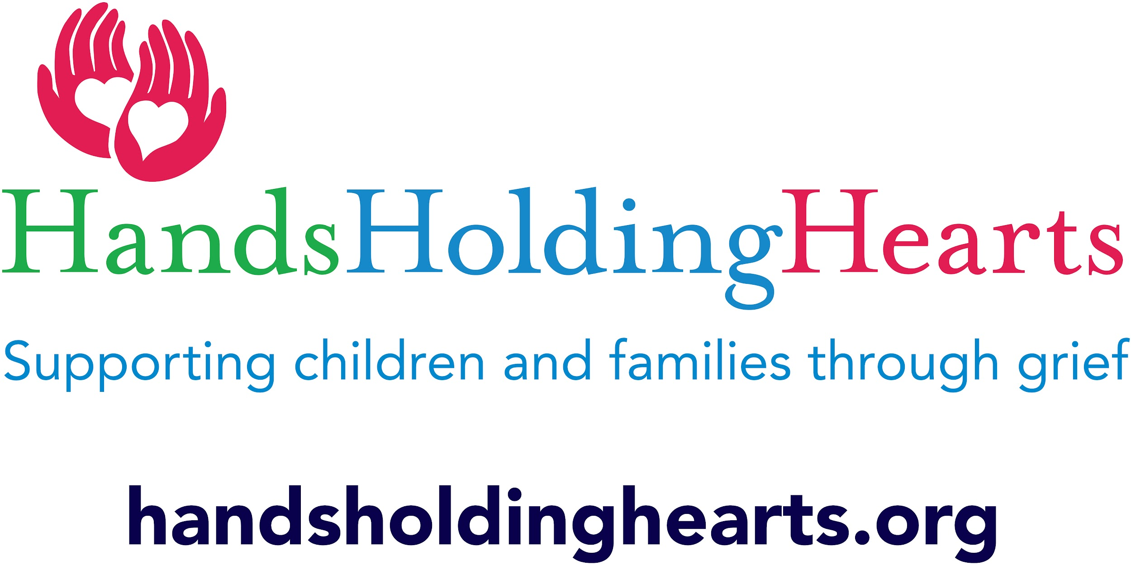

**Camp Healing Hearts Responsibility Contract**

Parent(s)/ Guardian(s): Please read this with your child(ren) and return with the application prior to the first day of camp.

1. **The STOP Rule**: If an adult or other camper says “Please Stop”, I agree to stop what

I’m doing immediately.

2. **The Buddy Rule**: I will always be sure that a buddy or a counselor is with me or

knows where I am at all times. In addition, I understand that I need to stay with the group when we are doing scheduled activities.

3. **The Group Member Rule**: I understand I need to respect my group members and

counselors when they are sharing information. I will wait until that person is done speaking to talk.

4. **The Respect Rule**: I promise I will not intentionally hurt anyone or make them feel

uncomfortable with my words (put downs, teasing, name calling) or my actions

(hitting, shoving).

5. **The Pass Rule**: I understand that if I do not want to participate in an activity or

discussion I can pass, however, I must stay with my group.

**Consequences:**

**Step 1**: If I am having a hard time with anything, I understand I can ask for help from a counselor who can try to help me follow the rules, or if I need support.

**Step 2**: If I cannot follow the rules after help from a counselor, I will be removed from the group & meet with a counselor individually- your guardian will be called. I agree that these rules are for my safety & the safety of others at the camp and I will follow them to the best of my ability.

**Step 3**: If I continue to not be able to follow the rules above, my guardian/parent will be called to pick me up & we will discuss if I am still able to return to Camp Feeling Better or not.

Camper Signature:___________________________________________________

Parent/Guardian Signature:____________________________________________