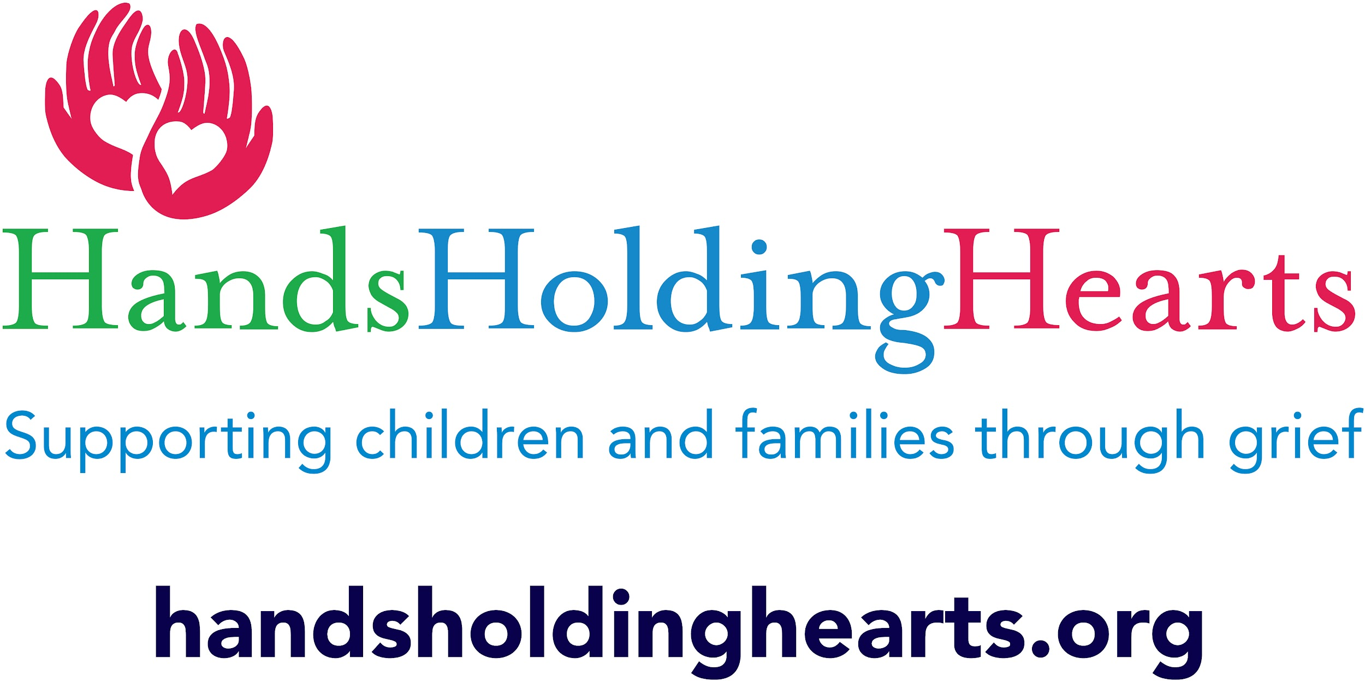

Dear Camper and family:

Thank you for your interest in our Camp Feeling Better. We hope that the camp’s activities will help your child mourn their loss while learning to move towards an emotionally healthy life. We will address the emotional, physical, & spiritual aspects of grief by using therapeutic activities and discussion. The camp will also afford your child(ren) the opportunity to meet other children who are also grieving. Our hope is that the connections they make at camp will continue throughout the year as the children return for other activities and groups that we offer.

The camp will run from July 28th-30th. Camp will begin Friday, July 28th at 6pm as we engage in a “meet & greet” with the children, families,therapists & volunteers. July 29th & 30th we will hold camp from 9a-12p. Staff will be available for 15 mins before & after camp to answer any questions that may arise. Please make sure that your child is wearing sunscreen, has eaten, and taken any medication needed before camp.

Below is the intended itinerary:

July 28th, 6pm: “Getting To Know You…” We will take time to get to know each other. We ask that you bring a picture of the loved one you lost on the first day of camp so we can all talk about the loss that brings us to this camp. We will discuss the camp rules & some of the activities we plan to offer over the next 2 days. Parents should plan to attend this session.

July 29th 9 am On this day we will focus on the emotions of grief. We will do an art project, some movement and deep breathing & offer ways for children to express their grief. This session is for the children solely.

July 30th 9am: This will be the final day of camp. We will continue to make some more craft projects and complete activities to help your child(ren) process their grief. At noon we will hold a memorial program so please join us in this activity as it is the culmination of the program. We will have pizza and cake to celebrate the end of camp. Please let us know how many family members will be attending the memorial so that we are sure to have enough food for everyone. After the program is over we ask that you complete an evaluation form so that we can tailor the next program to the needs and interests of the children attending the camp.

Please complete & return this form by July 20th. A screening for camp appropriateness may be required. While camp registration is $25, donations are always appreciated. Forms can be sent or emailed to the address below. Should you have any questions or need further information, please do not hesitate to call or email me. See you at camp!

Amy Keiper-Shaw LCSW, CT, GC-C, ACHP-SW

President, Hands Holding Hearts

118 N. State St. Newtown, Pa. 18940

(445) 444-5374

contact@handsholdinghearts.org