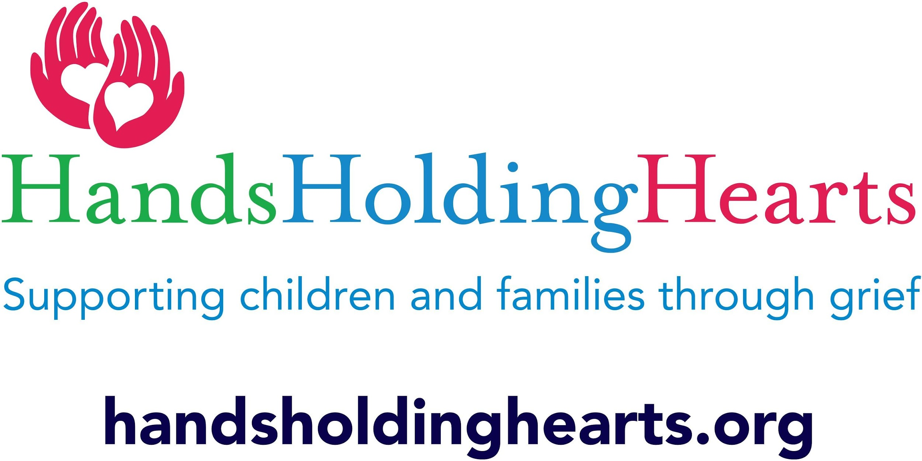

Hands Holding Hearts Volunteer Application v.191110
Our organization encourages and values the participation of volunteers who promote our mission of supporting grieving families. If you are interested in endorsing our mission and vision, please complete and return this application. Once received, you will be interviewed and trained to become a volunteer. Information on this form will be kept confidential and will help us find the most appropriate and satisfying volunteer experience for you.
Thank you for your interest in our organization!!

Please print
First Name: | Last Name:
Address: | City/State/Zip:
Telephone: | Cell Phone:
Email: | Date of Birth:

How did you hear about our organization?

What experiences are you hoping to gain from volunteering with Hands Holding Hearts?

Education (indicate highest level completed)

High School | College Degree | Graduate Degree | Business Degree | Tech / Vocational

Work/occupation Most recent employer (optional)

List previous volunteer experience:

Skills/ talents/ interests/ languages/ certifications (i.e. CPR, First Aid)

What interests you?
Marketing Board Member Representative to the Board
Fundraising Special Events Newsletter
Art Movement Workshops
Counseling Pet Therapy Other______________________________

References of people who know you well and can attest to your character (list name, address, phone number & email if applicable)
1:
2:

Volunteer availability: (Circle all applicable)
Monday(am/pm) Tuesday(am/pm) Wednesday(am/pm) Thursday(am/pm)
Friday(am/pm) Saturday (am/pm) Sunday (am/pm) As needed

In an emergency, notify:
First Name: Last Name:
Relationship:
Cell phone: Home phone:

List any special accommodations/allergies/concerns (if applicable):

As a volunteer of this organization I agree to:
- Hold as absolutely confidential all information I may obtain directly or indirectly concerning children and families. I will not seek to obtain confidential information from them,

- Become familiar with the organizational policies and procedures and uphold Hands Holding Heart’s Mission and philosophy.

- I am volunteering at my own risk and understand that its employees and other volunteers cannot assume any responsibility for any accident, injury, or health related problems that may arise from volunteering with this organization.

- I understand that any work I do is voluntary and I am not promised any monetary payments, future employment or compensation for the work I provide.

- I agree to serve any client who is served by this organization regardless of race, sex, creed or national origin.

- Be punctual and conscientious, conduct myself with dignity, courtesy, and consideration of others, and endeavor to make my work professional in quality.

- Maintain a well groomed appearance and follow the Dress Code in the Volunteer Manual

- Carry out assignments and ask supervisor’s assistance when needed,

- Take any problems, criticism, or suggestions to the Volunteer Coordinator

- Notify staff if I will be absent from an assignment.

By signing this application, I acknowledge that if I am over the age of 15 I I will need to provide a copy of my current criminal history and child clearance background check prior to volunteering with Hands Holding Hearts. This will be done at my own expense. I understand that Hands Holding Hearts reserves the right to terminate my volunteer status as a result of failure to comply with HHH Policies, rules, regulations and procedures, absences without prior notifications, unsatisfactory attitude, work, or appearance or any other circumstances which HHH would make my continued service as a volunteer contrary to the best interest of HHH. I had read each of the above conditions, and I agree to be bound by them.

Volunteer Signature_____________________________________________________ _________Date

Staff Signature _________________________________________________________ _________Date

Media Consent (Interview, Photograph, Video, Record,or Film)
I, ________________________________________________(please print your name), hereby authorize and give full consent to Hands Holding Hearts and their successors and assigns to publish, copyright and display, post any photographs, digital images, video, recording of interviews/statements taken by the agents of HHH in which I appear or am represented. I further agree that HHH or their successors or assigns may use or cause to be used these photographs for any exhibits, public displays, publications, newsletters, commercial art, social media and advertising purposes without limitations or reservations or any compensation whatsoever.

Volunteer Signature ______________________________________________________ ________ Date

If Minor, Signature of Guardian _____________________________________________ _________Date

Please return to Hands Holding Hearts at 118 N. State St. Newtown, Pa. 18940
or email to contact@handsholdinghearts.org

